
PATIENT NEWSLETTER
October 2025

Covid campaign Autumn2025

The eligibility criteria have changed this Autumn and as per the NHS guidance the eligible cohort are patients who are 75 years old and older and patients who are immunocompromised.

Join our PPG
We are still looking for new members!
Currently we are looking for PPG Chair, Deputy chair and other members!
To join please contact:
Data.cms@nhs.net or candmppg@gmail.com

Falls prevention project
West Mid Beds PCNs are working together to identify patients who may be at risk of falls or have experienced a fall. These patients will soon be invited to learn more about the support and services available to help them stay safe and independent. More information will be shared soon.
Continuity of care register
The Practice is due to start a project of identifying patients who would benefit from having named clinician involved in their care to help avoid recurrent hospital admissions and frequent GP appointments. The age group is 40-64 group that has multiple comorbidities and are at high risk of admission, polypharmacy. We will be sending letters to these patients with more information.

Protected Learning Time Day- Wednesday 19th November 2025

The Practice will be closed on Wednesday 19th November from 14.30pm onwards

OPEN - 8.00am until 14.30pm
CLOSED – 14.30pm onwards
RE-OPEN – 20th November 2025 at 8.00am

If you require medical assistance during the closure, please contact NHS 111 or visit your nearest pharmacy for advice. In case of an emergency, call 999

Current services provided by the Practice

- Spirometry & Feno Testing
- HRT Clinics every Thursday
- Blood tests for medication monitoring
- COPD reviews
- Extended Access clinics on Mondays, Thursdays and every other Saturday
- Weekly Physiotherapist clinic
- Weekly clinic with Mental Health Link worker

Smear Tests

From 1st July 2025, NHS guidelines are changing — anyone with a negative smear test will now be invited for their next screening every 5 years instead of every 3. This update applies to all age groups.

Xray’s at Bedford Hospital

Please note that from 27th October 2025 Bedford Hospital Xray department no longer accepts walk ins for Xray requested by the GP.

The department will contact you with an appointment via post once referred.

For more information, visit our website.

Private work

If you request any work not covered by the NHS Primary Care Services contract, your GP may complete it as a private service, and a fee will apply.

- Forms/Letters/Certificates
- Immunization (Hep B – travel only, Rabies, Encephalitis, ACWY meningitis)
- Adoption, Fostering & Child Minding
- Medicals such as Sports/Taxi/HGV medical, medical exams for insurance
- Driving (Fitness to drive, DVLA Medical)

We aim to complete such requests within 30 working days. If delays occur (e.g., due to GP leave or complex requests), we will let you know.

If you’d like information about our fees or have any other questions, please feel free to contact the Practice.

Cranfield Surgery update and response to recent Infocus newsletter
Response to Recent InFocus Newsletter Regarding Cranfield Surgery Opening

We are aware of a recent InFocus newsletter circulated by a local councillor suggesting that residents have been unable to register with Marston Forest Healthcare due to delays with the new Cranfield surgery.

We would like to reassure all patients and residents that our practice list remains open.
There are no restrictions on registration, and we continue to register new patients living within our practice boundary, including those who have recently moved to the area. Any suggestion that patients are unable to register with Marston Forest Healthcare is inaccurate.

As correctly noted by the councillor, the delays in opening the new Cranfield surgery are not due to the practice. The remaining delays relate to wider operational matters being managed by the Bedfordshire, Luton and Milton Keynes Integrated Care Board (BLMK ICB). These are outside of the control of the surgery.

We appreciate that this situation has caused frustration for the community—our team shares that frustration. We continue to actively engage with the ICB and are pressing for the earliest possible opening date. As soon as the ICB confirms this, we will communicate it publicly and directly to patients.

In the meantime, Marston Forest Healthcare remains fully open and continues to offer services from our existing sites, including registration for all eligible patients.

If any resident has been told they cannot register with our practice, please contact us directly so we can investigate it immediately.

Thank you for your patience and ongoing support.

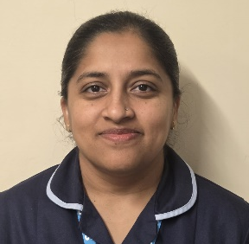
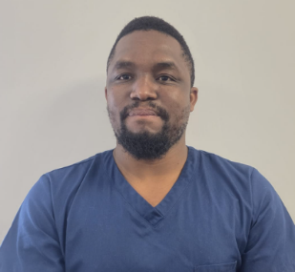

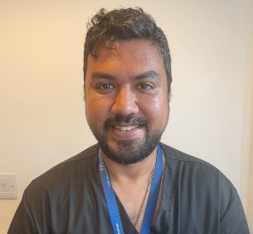
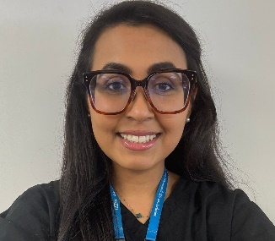
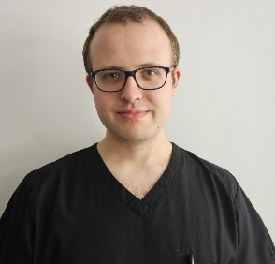
Dr Sacheen Nathwani
GP Trainee
FAREWELL
We extend our heartfelt gratitude for their dedication and service, and we bid them farewell with our very best wishes for the future.

Dr Gayathry Vijayaraghavan (Trainee GP) Leah Franklin (GP Assistant)
Dr Timothy Kearns (Trainee GP) Dr Ali Razam Ara (Salaried GP)
Dr Ibe Ikenna (Trainee GP)
Neena Chacko
Practice Nurse
Dr Marvin Mugwindiri - GP
Aymun Kiani
GP Assistant
Dr Amal Anwer
GP Trainee
Dr Luke Birtles
GP Trainee

Welcoming New Team Members

