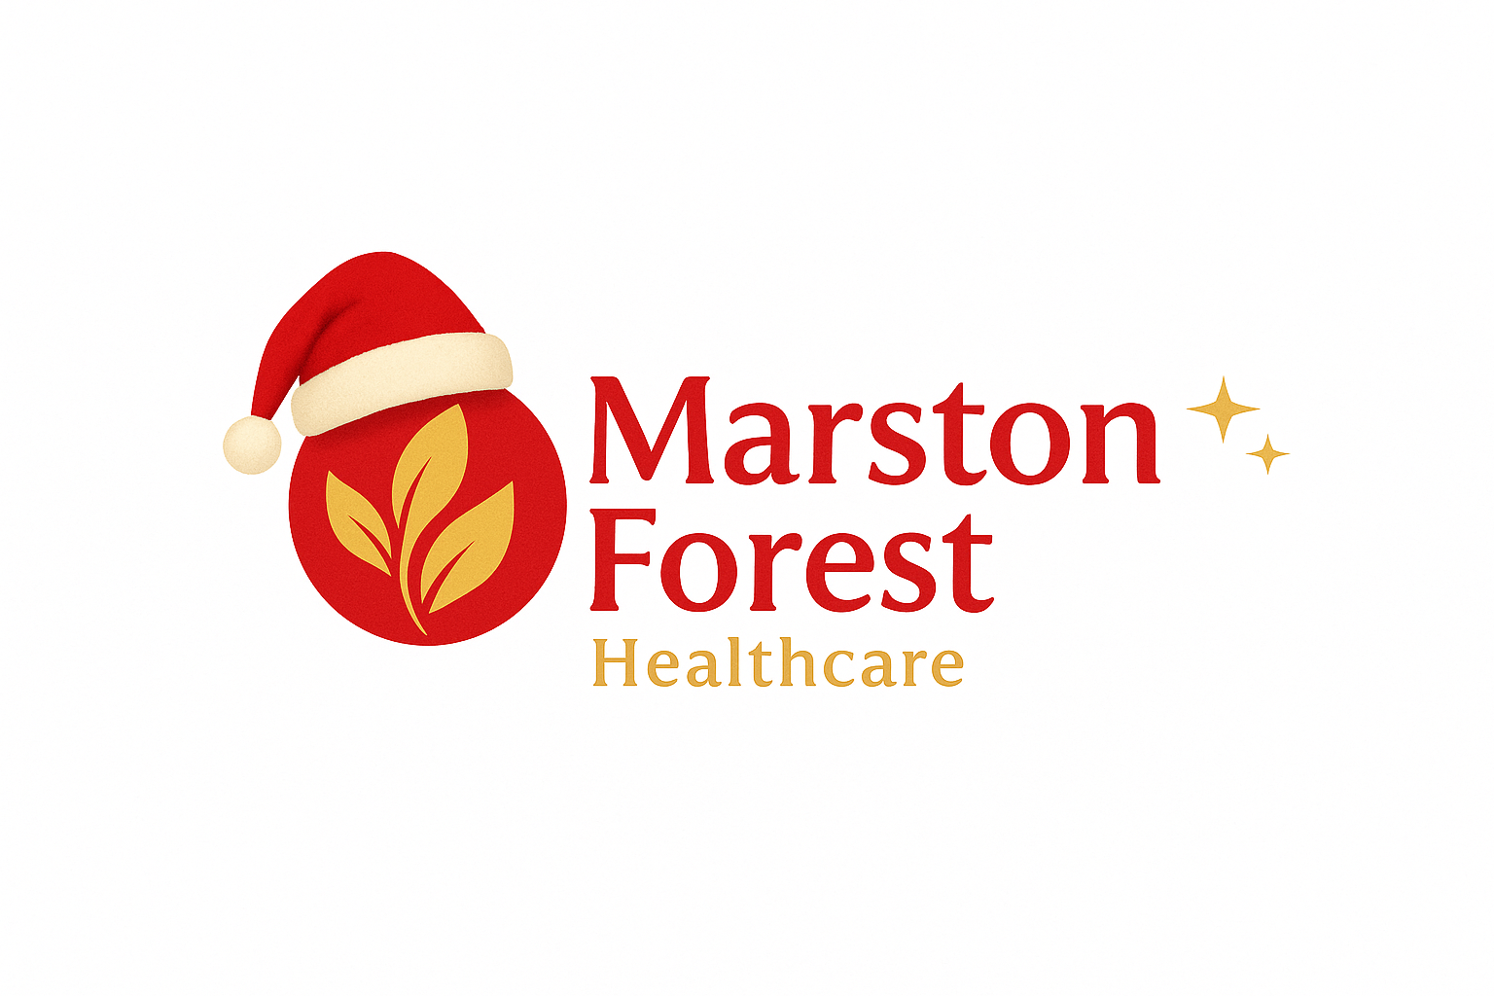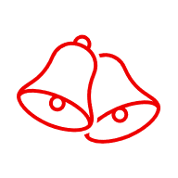
Patient Newsletter
November/December 2025

Repeat Prescriptions
To make sure you receive your repeat medications in time for Christmas, please submit your requests by 18th December 2025.

Please note that this does not mean prescriptions will be issued on the same day. Allowing extra time helps us manage the increased seasonal demand and ensures your medication is ready before the holiday period.

Thank you for your cooperation.

Join our PPG
We are still looking for new members!
Currently we are looking for PPG Chair, Deputy chair and other members!
To join please contact:
Data.cms@nhs.net or candmppg@gmail.com

Medication Monitoring Invitations & Why You May Receive Them
To help keep our patients safe, we use a system that identifies when blood tests, blood pressure checks, BMI or other health check reviews are due for certain medications. These checks need to be completed regularly, sometimes as often as every three months.
Our system automatically sends out up to two reminder invitations to patients who are due or overdue for their monitoring.
Recently, some patients have asked why they are receiving these invitations when they have already had their tests done or are being monitored by their hospital specialist. Please be reassured:
- If you are under hospital care for your monitoring, or have recently completed your tests, you may ignore the message.
- You are also welcome to inform our reception team, who can update your record accordingly.
- If you receive a second message soon after having a test, this may be because your results have not yet been processed by the system. In this case, you may simply disregard the invite or let reception know so we can update your records.
We appreciate your understanding as we continue to ensure all patients receive the monitoring needed to keep their medications safe and effective.

DNA ‘Did Not Attend’ Policy

As mentioned in our October 2025 Newsletter, unfortunately the number of patients who do not attend their appointments has increased.
Patients who will repeatedly miss their appointments may be at risk of being removed from the practice.
As per the Practice Policy, patients will get two warning letters if they continue missing appointments prior to removal. This covers period of 12 months.

MEDICATION CHANGES
NON-NHS SERVICES

Please note that we have recently increased our fees for non-NHS services. For more information, please contact the practice directly.

Current services provided by the Practice

- Spirometry & Feno Testing
- HRT Clinics every Thursday
- Blood tests for medication monitoring
- COPD reviews
- Extended Access clinics on Mondays, Thursdays and every other Saturday
- Weekly Physiotherapist clinic
- Weekly clinic with Mental Health Link worker

Recent message regarding SGLT2 inhibitors (medications ending in “-gliflozin”), such as dapagliflozin, empagliflozin, canagliflozin, and ertugliflozin
We understand that the information you received may sound worrying, but please be reassured that this was sent as routine safety advice for people taking an SGLT2 inhibitor. These messages are provided to ensure patients are well informed, not because there is a problem or expectation that this will happen to you.
The conditions mentioned are very rare. Most people take this medication safely and without issues. The advice is simply to help you recognise symptoms early in the unlikely event they occur, so you can seek medical help promptly.
If you are feeling well and have no symptoms, there is nothing to worry about and no action is needed. Please continue taking your medication as prescribed.
If you ever have concerns or experience anything unusual, you are always welcome to contact us for advice.

For patients who take Rybelsus tablet - Rybelsus® is now available in a new formulation that is absorbed better by the body. Because of this, the tablet strength (mg) will be lower, but the medicine works the same as your current dose. You will still take one tablet once daily.
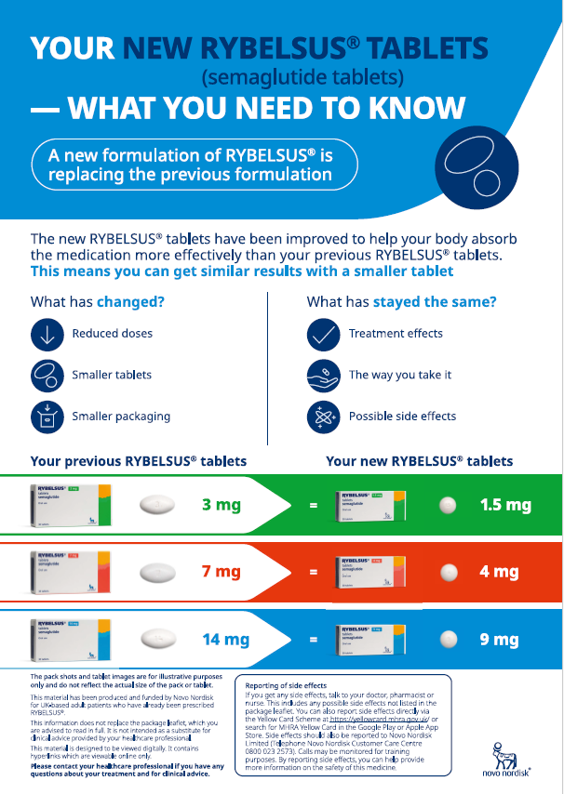

Next Month’s Newsletter

Please share your ideas and thoughts and any suggestions for topics to be included in upcoming newsletters

Please share directly to Data.cms@nhs.net or candmppg@gmail.com

We would like to wish you a Merry Christmas and all the best for The New Year

Please share your ideas and thoughts and any suggestions for topic to be included in upcoming newsletters

Please share directly to Data.cms@nhs.net or candmppg@gmail.com

