Marston Forest Healthcare

Cranfield – 137 High Street, Cranfield, Beds, MK43 0HZ
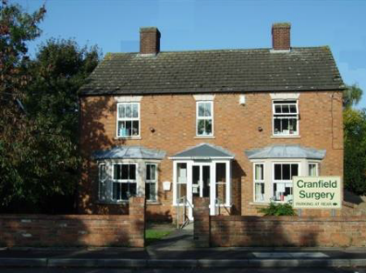
Marston – 59 Bedford Road, Marston Moretaine, Beds, MK43 0LA
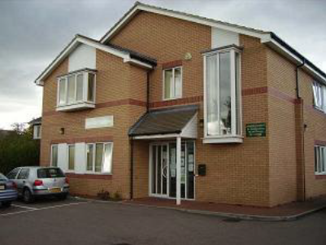

Website: www.martsonforesthealthcare.co.uk
Email: data.cms@nhs.net
Phone: 01234 766551

Opening hours
Cranfield: 08.00 - 18.00
Marston: 08.00 – 18.30

Out of hours please call 111

In case of a life-threatening emergency, please call 999

Our Team

Partners
Dr Imran Ismail (Male)- MBBS (London), MRCP (1) MRCGP (UK)
Amir Ismail (Male) – Clinical Pharmacist
Sadaf Ismail (Female) – Clinical Pharmacist
Dr Gautham Adusumilli (Male) - MBBS MRCGP Dip.PAEDS

Salaried GPs
Dr Oreoluwa Ogunrinde (Female) - MBBS MRCGP PGDip Med Ed MPA BHS
Dr Marvin Mugwindiri (M) Salaried GP
Dr Pooja Venugopal (F)

Trainee GPs

Dr Amal Anwer (F) GP trainee
Dr Sacheen Nathwani (M) GP trainee
Dr Patiya Green (F) GP trainee

Other Clinical Staff
Sheena Cheeramkulathu – Practice Nurse
Neena Chacko – Practice Nurse
Nick Vaughan – Community Paramedic
Mairead Hartnett – Advanced Clinical Practitioner
Suhayb Iqbal – Clinical Pharmacist
Fiona Blair – Healthcare Assistant
Physiotherapists
Midwife

Management Team
Quality Assurance & Peer Review Manager and PCN Digital & Transformation Manager, Green Vale Health PCN
Anna Zajickova
Practice Clinical and Education Manager
Huma Iqbal
Finance Manager
Nadia Ali
Digital & Transformation (D&T) Manager
Georgina Price
Clinical Administration Team
Sharon, Denise, Sana, Nolwazi, Allison, Debbie, Evangeline, Leah

About Us

Welcome to Marston Forest Healthcare, serving a population of 10,500 patients in Cranfield and the surrounding villages. The Practice originally consisted of one surgery at Cranfield, but due to a rapidly growing population a second surgery was opened in Marston Moretaine in 2002.
The practice is part of the Bedford, Luton and Milton Keynes (BLMK) Integrated Care Board (ICB). We are joined with Flitwick Surgery in Greenvale Primary Care Network (PCN).

The practice covers a rural area and villages in our catchment area are shown below. We can only accept patients who are within our boundary area.

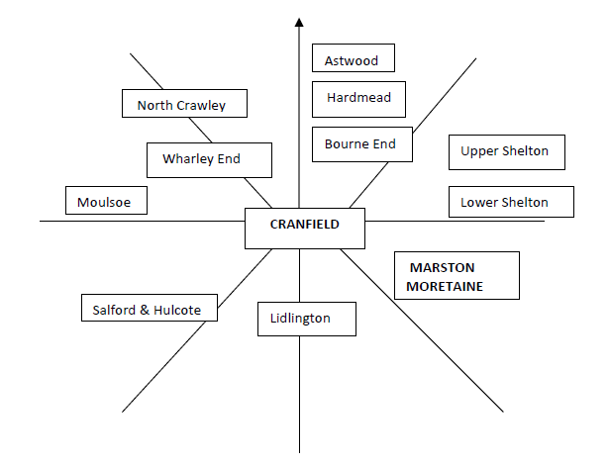

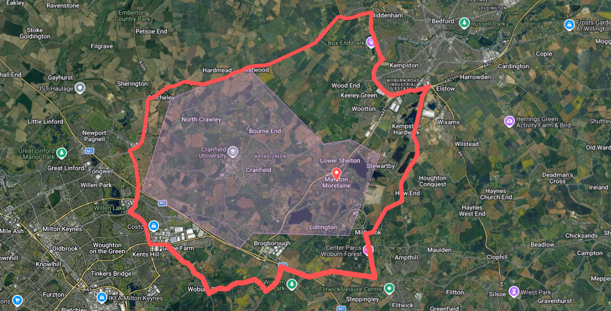

Services we provide include:
Medical advice
Prescribing medication
Vaccinations
Minor surgical procedures
Care for ongoing, chronic or longstanding conditions.
Phlebotomy
Travel vaccinations
Antenatal clinics
Physiotherapy

Practice Nurse and Healthcare Assistant Appointments
Please call the surgery to book appointments with the Practice Nurses or Healthcare Assistants.

GP, Minor Illness and Paramedic Appointments
Please use out total triage system Anima if you would like an appointment with the GP, Minor Illness Clinicians or Paramedic.
This can be accessed via the surgery website from 7.45am or if you are unable to complete online you can call the surgery from 8am.
This system allows the GPs to triage the requests that come in and allocate them to an appropriate clinician according to need and urgency. This will either be a face-to-face appointment or a telephone call.

Home Visits
Home visit requests should be completed through Anima. It will be triaged in the same way and appointment booked.

Test Results
These will be available via the NHS App or your online records once they have been reviewed by a clinician. You can call the surgery after 2pm to ask about your test results. Should you wish to discuss any results with a clinician, please raise a case via Anima. Please allow a week for the results to arrive.

Repeat Medication
Please request any repeat medication using the online services, the NHS App, by emailing the surgery or dropping a written request at the surgery. Please allow 3 working days for your medication to be available from your nominated pharmacy.

Non-NHS work and fees
There is usually a charge for non-NHS work (private insurance reports/to whom it may concern letters etc.). The doctors do this work outside of their consulting hours. The charge will vary depending on the work involved. You will be informed of the charge when you make the request. It will take approximately 2-3 weeks once payment has been received for the work to be completed.

Registering at the surgery
You can register with the surgery via our website if you are within our practice area. You can also pick up a registration pack from reception if you are unable to complete online.

Responsibilities of patients
Please be polite to all members of our staff. The NHS has a Zero Tolerance policy. Any physical or verbal violence will not be tolerated and may result in your removal from our list. Please update the surgery to any change of name, address, or phone number. Please attend appointments, or if unable to attend please cancel the appointment in advance.

Patient Participation Group (PPG)
We have an active and supportive PPG. They meet on average once a quarter. If you are a patient, you can be involved in the PPG. For further information, please visit our website and complete an online form.

Complaints, Compliments and Suggestions
We have a Practice based system in place to handle any complaints or suggestions. Please email the surgery to raise any issues and we will review them. We are constantly seeking to improve the services we deliver.
Staff training
Once a month the surgery, along with other local surgeries, will be closed from 14.30 – 18.30 for mandatory training. This will be shared on our website and through the PPG.

